1. The Nernst equation indicates that the membrane potential does not depend on the charge of the ion.

**A**Correct. the Nernst equation only depends on the ion concentration  not their charge

**B**Incorrect. The charge of the ion influences the membrane potential (Correct Answer)

**C**Correct. the Nernst equation only depends on the temperature

**D**Incorrect. the charge of the ion only determines the sign (positive or negative) of the membrane

1. Assume that only chloride ions are present and their intracellular concentration is much higher than their extracellular concentration.  Will the membrane potential be negative, equal to 0, or negative?

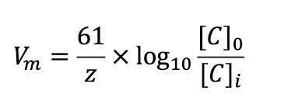

**A** Positive (Correct Answer)

**B** 0

**C** Negative

**D** Insufficient data to answer the question

1. The opening of  voltage-gated potassium channels is responsible for which part of the action potential

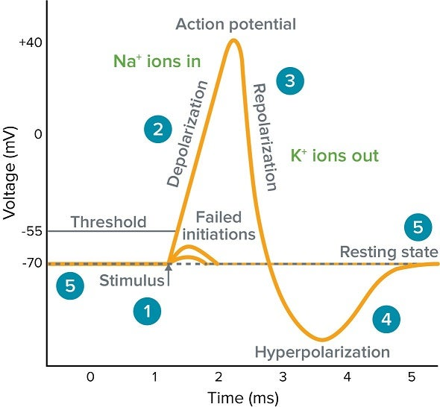

**A** Depolarization

**B** Repolarization(Correct Answer)

**C** Initiation of the action potential

**D** Voltage-gated potassium channels are not involved in the generation or propagation of an action potential

1. The potassium leak channel is responsible for the pumping of potassium ions inside the cell

**A** Correct. Every three sodium ions , two potassium ions are pumped inside the cell

**B** Incorrect. TRPV-1 channels are responsible for pumping potassium inside the cell

**C** Correct. the potassium leak channels is essential for the propagation of an action potential

**D** Incorrect. the sodium/potassium pump is responsible for pumping potassium inside the cell(Correct Answer)

1. According to the conformability mechanics model, two thin membranes with the same thickness and the same membrane-substrate interfacial adhesion, one made of Ecoflex (Young’s Modulus = 92 Kpa) and the other of Polyimide (Young’s Modulus = 2.8 Gpa), show the same conformability with the target substrate.

**A** Correct. The mechanical properties of a membrane do not affect its conformability therefore the Young’s Modulus is not an important parameter in the model.

**B** Incorrect. The stiffer membrane (higher Young’s Modulus) shows better conformability to the substrate than the softer membrane (lower Young’s Modulus).

**C** Correct. Regardless of the membrane material, thickness and adhesion are the only parameters that affect conformability.

**D** Incorrect. If thickness and adhesion are kept constant, reducing membrane stiffness is a good strategy to improve conformability. Correct Answer)

1. Photoplethysmography (PPG) is used in wearable devices to detect volumetric changes in blood at the surface of the skin and calculate the heart rate.

**A** Incorrect. Wearable devices only rely on skin electrodes for calculating the heart rate.

**B** Correct. PPG is integrated in most wearable devices to calculate the heart rate. Correct Answer)

**C** Incorrect. PPG detect changes in sound at the surface of the skin to calculate the heart rate

**D**, Correct. PPG is the only technology able to provide accurate and reliable heart

rate measurements

1. EMG is a diagnostic procedure to measure electrical activity in the brain.

**A** Correct. It is achieved by connecting electrodes to the head

**B**, Incorrect. EMG is a procedure for measuring the electrical activity produced by

skeletal muscles Correct Answer)

**C**, Incorrect. EMG is a procedure for measuring the heart electrical activity

**D**, Correct. It requires electrodes implanted deep into the brain